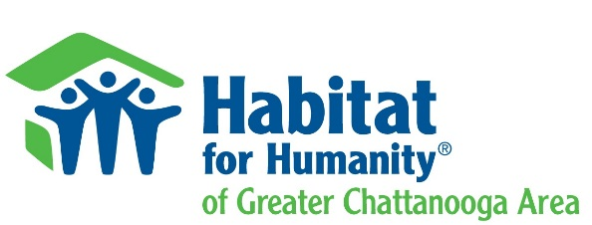
Habitat for Humanity Greater Chattanooga Area
STATEMENT OF PROCUREMENT GUIDELINES AND STANDARDS
All procurements must meet the following standards:
- Habitat for Humanity Greater Chattanooga Area’s (HFHGCA) officers, employees or agents will neither solicit nor accept gratuities, favors or anything of monetary value from the contractors or potential contractors. No employee, official or agent of Habitat can participate in selection or in the award or administration of a contract if a conflict of interest, real or apparent, would be involved. Such conflict arises when a financial interest in an organization is held by:
The employee, officer, or agent involved in making the award;
His or her immediate family
His or her partner; or
Any organization, which employs, or is about to employ any of the above.
- HFHGCA will solicit bids for sub-contracted work through phone contact inquiries, email/web-sites, letters and/or advertisement.
- HFHGCA will solicit quotes for material more than $500 per individual item through phone contact inquiries, email/web-sites, letters and/or advertisement.
- HFHGCA will take affirmative steps to inform small, minority, and women’s businesses of projects and bid opportunities.
- HFHGCA must solicit from an adequate number of qualified sources to permit reasonable competition.
- HFHGCA shall require copies of valid contractor’s licenses (where work performed requires permitting) and certificates of General Liability and Workman’s Compensation insurance.
- HFHGCA will review all received bids and will maintain records sufficient to detail the significant history of procurement. Any or all bids may be rejected when there are sound business reasons that to do so would be in the best interest of the program.
- Awards will be made only to responsible contractors who possess the ability to perform successfully under the terms and conditions of a proposed procurement. Consideration must be given to such matters as contractor integrity, experience, past performance, adherence to codes, regulations and Section 3 compliance and have demonstrated fair business practices.
- Notification of bid determination will be given to all companies/individuals submitting bids.
- Due to HFHGCA’s use of house standards such as square footage, floor plans and house designs, any bid received will be considered for comparable future builds with acknowledgement of price adjustments due to time and market changes.
- Affiliate's obligations under Sec. 3:
      - To the greatest extent feasible, provide job training and employment opportunities to low- and very low-income persons in the affiliate's service area.
      - Construction sweat-equity may count as job training.
      - As much as reasonably possible, see that Sub-Contractors adhere to HUD/Section 3 guidelines.
- Contracts may be terminated for default as well as conditions beyond the control of Habitat.

